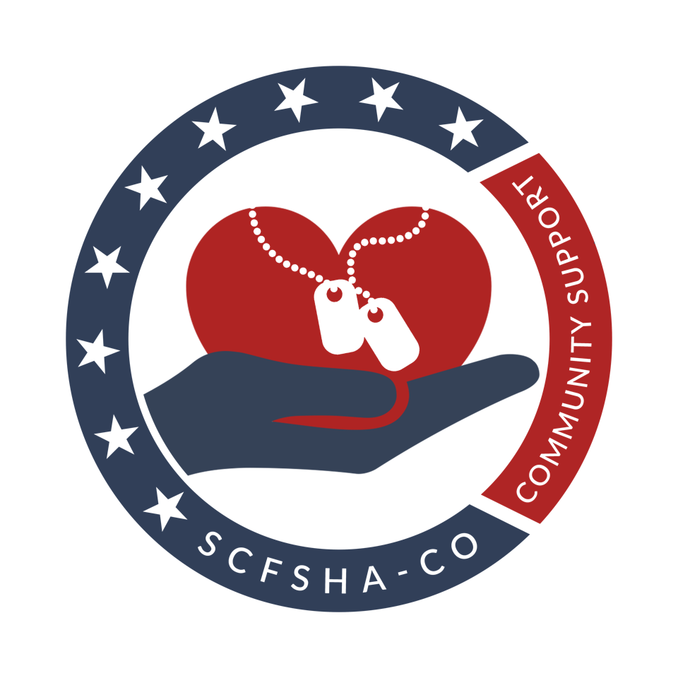

SCFSHA CHARITABLE ORGANIZATION

COLLEGE UNDERGRADUATE

SCHOLARSHIP APPLICATION PACKET

2021-2022 ACADEMIC YEAR

TABLE OF CONTENTS
(2021-2022)

Scholarship Process at a Glance |  |  | i
Application Checklist |  |  | ii
Basic Guidelines |  |  | iii
Privacy Act Statement |  |  | 1
Personal Information |  |  | 2
College/University or Trade/Technical School Information |  |  | 3
Community Service/Awards/Honors Information |  |  | 4
Job Experience & Hobbies Information |  |  | 5
Letter of Recommendation Instructions & Cover Sheet |  |  | 6

SCHOLARSHIP PROCESS AT A GLANCE
(2021-2022)

The Spouses’ Club of the Fort Sam Houston Area’s Charitable Organization (SCFSHA-CO) awards scholarships annually to select college students to assist them in obtaining college, university, trade or technical school funding.

- Eligibility - applicants must meet the following criteria:
- Must be accepted or anticipate acceptance as an undergraduate by a college, university, trade or technical school.

- Must use the scholarship no later than the end of the 2023 spring session at an accredited college, university, trade or technical school.

- Must not already be the recipient of a full-tuition scholarship which includes room and board.

- Must possess a valid military ID card.

- Must be a Family member of (1) active duty military or DOD civilian assigned to Fort Sam Houston or Camp Bullis or one of their tenant units; (2) active Armed Services personnel on a short tour assignment whose family members remained in San Antonio area, (3) geographically separated family due to a non-sponsored assignment, (4) retired or deceased Armed Services personnel wherein the family members reside in San Antonio area.

- Selection Process
- Five independent representatives of the Fort Sam Houston community will review, evaluate and score the completed applications. The SCFSHA-CO Scholarship Committee, under the direction of the VP Scholarships, will tally the judges’ scores and develop from those scores an Order of Merit list (OML), which will be used to determine scholarship award recipients and the dollar amounts of the awards. Prior to the evaluation process, all applicant identifiers (i.e., name, address, etc.) are removed from applications. Applications are identified by a number code, and all applications are handled in a confidential manner.
- Selection of SCFSHA-CO Scholarship recipients is made without regard to race, sex, religion or national origin.

- Recipient Information
- Notification of receipt of application will be sent to each applicant.

- Scholarship recipients will be notified no later than April 15th regarding the status of their application.

- Scholarship recipients will receive instructions regarding presentation of scholarships.

- Upon proof of enrollment, scholarship funds will be sent directly to the institution of higher learning.

- Any student accepting a full-tuition scholarship including room and board is ineligible to receive funds from the SPOUSES’ CLUB OF THE FORT SAM HOUSTON AREA’S CHARITABLE ORGANIZATION (SCFSHA-CO) and must notify the SCFSHA-CO (in writing) of his/her acceptance of that scholarship. The SCFSHA-CO will then award the scholarship to the next applicant on the OML.

i

APPLICATION CHECKLIST
(2021-2022)

The following items must be completely filled out with the appropriate information and included in the packet you submit to SCFSHA-CO NLT MARCH 1st. Incomplete or late applications can not be accepted.

- The Privacy Act statement (page 1)

- The Personal Information (page 2)

- The College/University or Trade/Technical School Information (page 3)

- The Community Service Information (page 4)

- The Job Experience and Hobbies Information (page 5)

- Each applicant will submit a letter of recommendation as part of their completed application. The letter will be prepared in compliance with the guidelines on page 6 of this application packet.

- The typewritten essay, as outlined in Basic Guidelines #3 (page iii)

- An official college transcript (sealed in an envelope) from your most recently completed semester. The transcript must have the issuing school’s seal imprinted on the document.

- Each applicant will include a photocopy of the front of the applicant’s valid military ID card. The applicant’s photo must be sufficiently clear and the name and expiration date must be legible.

- Applications will be submitted with the documents previously mentioned in this checklist and placed in the order they are mentioned (i.e., the first item in an applicant's packet will be the completed privacy act statement and the last item will be the copy of the ID card).

- The applicant will alert the VP Scholarships by email when their application has been sent, scholarships@scfsh.org.

ii

BASIC GUIDELINES
(2021-2022)

- Take the time to read all the instructions carefully and check your work thoroughly before submitting your application.

- The awarding of scholarships is competitive; therefore, we recommend that every effort be made to ensure all documents prepared by the applicant are error-free.

- All applicants will submit an essay as part of their applications. In five hundred words or less, the applicant will address the following question:

Who in your life has been your biggest influence and why?

This essay will be typewritten and double-spaced. Neatness, grammatical accuracy and creativity should be given particular emphasis in the preparation of this essay. The essay will be placed just in front of the applicant's copy of his/her ID card.

- All required documents and the completed application must be mailed in ONE envelope to:

SCFSHA-Charitable Organization
ATTN: VP Scholarships
P.O. Box 340209
Fort Sam Houston, TX 78234-0209

- Unless specifically addressed in the instructions for each item to be submitted, applicants will limit their responses to the space provided. Information that does not fit into the allotted space should not be submitted and will not be considered.

- APPLICATION DEADLINE. Applications must be postmarked NLT March 1st. A minimum of first class postage should be used on the application to ensure timely delivery.

- The applicant will alert the VP Scholarships via email at scholarships@scfsh.org when their application has been sent.

- Should you need additional information, the contact VP Scholarships via email scholarships@scfsh.org .

TWO SCHOLARSHIP CATEGORIES: Academic & Community Service

The SCFSHA-CO recognizes that every student has strengths and abilities in differing areas; and for this reason, two scholarship categories have been developed: Academic and Community Service. Students have the liberty to choose which scholarship best suits their strengths and abilities. If the student would like to apply for both categories, they will be graded and placed onto each Order of Merit List separately for consideration. Please indicate your choice with your personal information on page 2.

iii

PRIVACY ACT STATEMENT
(2021-2022)

Reference application for the SPOUSES’ CLUB OF THE FORT SAM HOUSTON AREA’S CHARITABLE ORGANIZATION (SCFSHA-CO) SCHOLARSHIP.

- Authority: Title 5, United States Code (USC) 552A.

- Principal purpose: to obtain information from the SCFSHA-CO scholarship applicants.

- Routine uses: To be used as the basis for evaluating student applicants in order to determine who is best qualified to receive SCFSHA-CO scholarships. The SCFSHA-CO scholarships are awarded based upon the evaluation of the whole person (i.e., not just academic performance).

- The submission of information requested in this packet is necessary in order to provide the basis for evaluation. Failure to provide all requested information (including a signed and dated privacy act statement) will result in the applicant's submission being removed from consideration.

- I authorize my school, state and federal agencies to release any information they may have concerning me to the SCFSHA-CO Scholarship Committee.

- I have not been, nor am I now, involved in any infraction of policies or rules of the institution of higher learning at which I will use this scholarship.

- I certify that the information furnished in this application is true and complete to the best of my knowledge, and that the student essay was written only by me.

- I consent, in the event I am awarded this scholarship, to SCFSHA-CO’s use of my name, photo, and scholarship information for their promotions.

- I agree that if I am awarded a full-tuition scholarship to include room and board, I will not accept a scholarship award from SCFSHA-CO.

______________________________________________
APPLICANT’S SIGNATURE
____________________
DATE

______________________________________________
PARENT/LEGAL GUARDIAN’S SIGNATURE
____________________
DATE

1
PERSONAL INFORMATION
(2021-2022)
Applicant’s Name:
(Last) (First) (Middle)

Date of Birth:

Mailing Address:

Phone Number:  (include area code) | Email:

Sponsor’s Full Name/Rank:

Branch of Service:  (indicate here if DOD) | Active/ Retired/ Reserve/ National Guard/ Deceased  (circle one)
Phone Number:.  (include area code) | Email:
Mailing Address (if different than above):
Is your parent a member of the SCFSHA?
- Yes Name of parent that is a member__________________________________________________
- No

What is your present or intended major?

What is your intended career?

If you have not made this decision, what three careers interest you the most?

1.

2.

3.

For which scholarship category would you like to be considered?
- Community Service
- Academic
- Both
2

COLLEGE/UNIVERSITY OR TRADE/TECHNICAL SCHOOL INFORMATION
(2021-2022)

In chronological order, list all schools you have attended past the high school level. Include High School if you have completed less than 30 semester hours of college credit or the equivalent of technical school.

Date(s) | Name of Educational Institution | Location
3

COMMUNITY SERVICE/AWARDS/HONORS
(2021-2022)

List all college and volunteer activities/awards/honors earned during the last four years that will aid the selection committee in evaluating your application. Please include all leadership experiences and/or positions held during this time.

Year | Organization & Duties | Location
.

4

JOB EXPERIENCE & HOBBIES INFORMATION
(2021-2022)

List all job experience (including self-employment) for the past four years. At a minimum, please include the employer's name and address, dates of employment, hours per week you were employed and your positions.

Employer/Address | Dates of Employment | Hours per Week | Position Held/ Duties

List all hobbies or interests not previously identified.

Hobby/Interest | Additional Information

5

LETTER OF RECOMMENDATION INSTRUCTIONS & COVER SHEET
(2021-2022)

This letter must be from a faculty member, employer, or other community member whom the applicant has known at some time during the past five years. The author may not be related to the applicant. ONLY ONE LETTER IS AUTHORIZED PER APPLICATION.

Cover Sheet

Please fill in this information and attach this cover sheet to your letter of recommendation.

Applicant’s Name:

Author of Recommendation:
(name, title/occupation)
Phone Number:
(including area code)
Relationship of Author to Applicant:
(i.e. employer, mentor, etc.)

Instructions for the Author of the Recommendation Letter

- Please be sure that the information provided above is legible.

- Please address the following areas in your letter: intellectual promise, motivation, leadership, integrity, interpersonal relationship skills and responsibility.

- Please DO NOT use the applicant's name anywhere on your letter (hence, the cover sheet).

- Limit your letter to no more than two, single spaced, typewritten pages.

- After you have completed and signed your letter, please fill out and attach this page to the front of your letter. We also ask that you place your letter inside a sealed envelope and sign your name over the seal. Finally, write the words: "Recommendation Letter" and the student's name on the front of the envelope.

- Please be aware that your letter of recommendation must be included with the entire application that the student submits (the student is authorized to mail in only ONE large envelope containing the entire application with supporting documents and cannot mail in your letter of recommendation, or any other document, separately).

- Please provide your (sealed) letter to the applicant in time for it to be included in the entire application packet. The entire packet must be postmarked NLT March 1st.
6

